Quit Facts

国旗 national flag -- "Old Glory" "The Stars and Stripes"

自由女神像 the statue of liberty

国花 Rose

国鸟 The Eagle

国树 Oak

Hollywood

Location

States

3 Geographic Divisions

**Quit Facts**

国旗 national flag -- "Old Glory" "The Stars and Stripes"

50 stars -- the 50 states

13 stripes -- the 13 original colonies

作者-- Betsy Ross

自由女神像 the statue of liberty

located on liberty island in New York Harbor

"Liberty Enlightening the World"

国花 Rose

国鸟 The Eagle

国树 Oak

Hollywood

walk of fame

New York

Big Apple

San Francisco

The Golden Gate Bridge

Chincago

The Windy CIty

New Orleans

Big Ease

Las Vegas

The city of sin

dont have a uniform time 东部比西部早3小时

**Location**

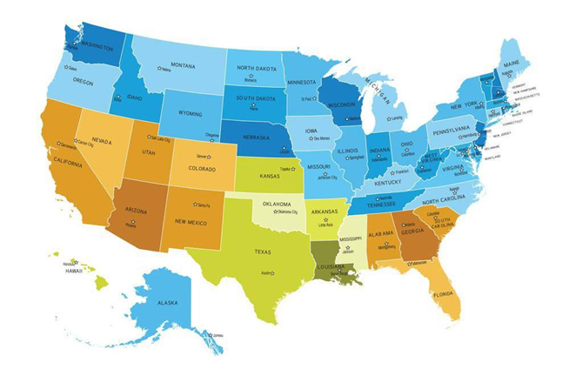

In the central part of North America (except Alaska and

Hawaii);

— Canada on the north

— Mexico and the Gulf of Mexico on the south

— Atlantic Ocean on the east

— Pacific Ocean on the west

Total area — a little less than 9.6 million square kilometers;

50 states and the federal district of Columbia

**States**

original 48 states

Alaska and Hawaii, separated from the continent, became

the 49th and 50th states in 1959.

— Alaska borders on northwestern Canada

— Hawaii lies in the central Pacific Ocean

Alaska — the largest state

Rhode Island — the smallest state

Texas — the largest on the mainland

**3 Geographic Divisions**

Central part -- between the applachians in the east and the rocky mountains in the west

-- 1/2 of America's landmass of the continent

-- stretch from the Great Lakes in the north to the Gulf of Mexico in the south

-- drained by the Mississippi and its tributaries 5 great lakes and Niagara Falls

Western part -- High plateaus and mountains ,extending from canada through the western part of the United States to Mexico and further south

-- 1/3 of the territory

-- Rocky mountains

Eastern part -- the highland formed by the Appalachian Range

-- 1/6 of the territory

-- relatively low,with an average altitude of 800 meters above sea

-- highest point is 6,684 ft.

**The Mississippi River**

-- Father of Waters

**The Great Lakes**

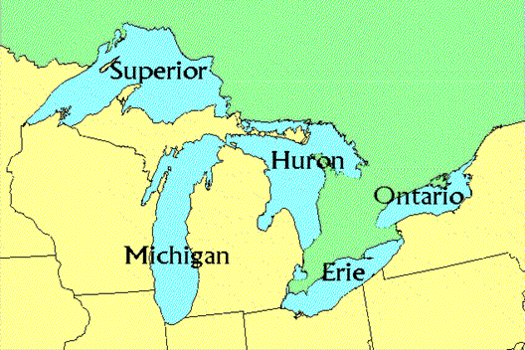

-- the most important system of inland waterways in the world

-- Lake Michigan -- wholly within the United States

-- part of the national boundary betweeen the United states and canada runs though this chain of lakes

--HOMES

**Races**

-- the third most populous nation in the world,ranking behind China and India , 2006 , 300 million

-- The Indians The Whites The Blacks The Hispanics The Asian-Americans

**The Indians**

-- 10 million Indians in North America When Columbus arrived

-- Westward movement -- the destruction of the Indians

-- Today about 2.4 million Indians

-- Abour 1/3 of them live on reservations , land that was set aside for them.The rest lives in cities

-- Poverty and unemployment are major problems, especially on the reservations

**The Whites**

-- Descendants of Europeans

-- White Anglo-Saxon Protestants who were largely responsible for the winning of America's independence

-- English -- official language(not by law)

**The Black**

-- 8 million black people were brought to America from Africa as slaves from 1620-1820

-- work on plantations or large farms of the South

-- poor and suffer from poverty

-- Today the black account for about 12.85% of the population

-- Many of them live in the South and in cities of Northeast and Midwest

**Hispanics**

3 major Hispanics groups

-- Mexican Americans

-- Puerto Ricans

-- Cuban Americans

**Asian Americans**

-- the third largest racial minority , the two largest Asian American ethnic groups are Chinese Americans the Filipino Americans

-- the Asian-Americans are the fastest-growing racial and ethnic group in the United States

-- model minority, several of them have won Nobel Prizes

-- many of them are found in the major coastal cities of the US such ad San Francisco Los Angeles

and New York City

-- Chinese

-- Gold Rush first major wave of Chinese immigrants. arriving in San Francisco,1849

-- model minority

**The Melting Pot/The Salad Bowl/Pizza**

-- speak almost the same kind of English

-- have similar habits and manner

**The American Dream**

**American Values**

**Characteristics of Americans**

-- Stereotypes about people of each region

-- New Englanders:stern and self-reliant

-- Southerners:gracious and leisurely

-- Westerners:casual and friendly

-- Mobility

-- moving 14 times jop-hopping 9/10 times

-- The Englishman: “a person who does things because

they have done before”

The American: “a person who does things because they

haven't done before”

-- Self-made

-- Belief in gaining wealth and possession through hard work

-- 90% of the population: well-off

-- 10% of the population: below the "poverty line"

-- being more race-conscious than class-conscious

-- dressing correctly

-- being sentimental,intensely patriotic